Wastewater Collection
Student Activity Sheet
Task 1: Pipe Capacity
Sewers must be sized to handle the area that they will serve. When the service area is new, engineers use unit flow rate factors to determine the flowrate the sewer will need to handle.
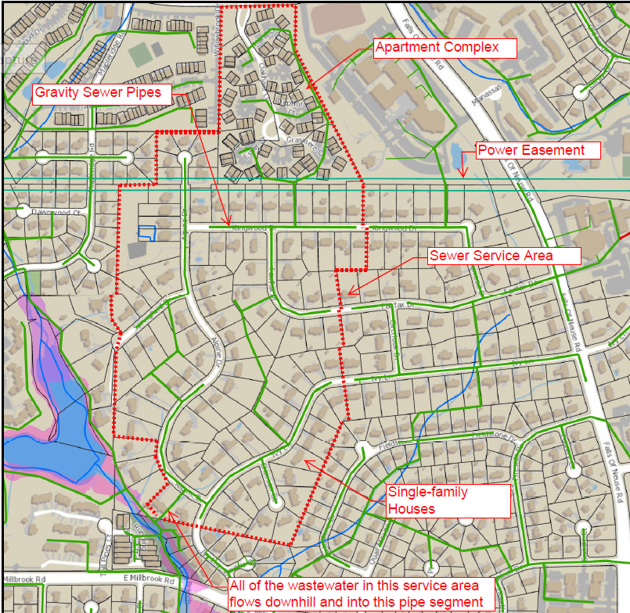

Here are some typical average daily flow rates (in gallons per day; GPD) by type:
• Single family residential: 250 GPD per house
• Apartments: 240 GPD per apartment unit
• Office building: 25 GPD per employee
• Restaurant: 40 GPD per seat
• Hotel: 120 GPD per room
• Stadium/Auditorium: 5 GPD per seat

Based on these factors, along with the number and types of development in the service area, we can calculate the average daily flowrate leaving the service area. However, sewer pipes need to be sized for peak flowrates, not just average daily flowrates. We apply a peaking factor to account for this. When there is no site‐specific data available, a typical peaking factor would range from 2.5 to 3.0 times the average daily flowrates. To estimate the peak flowrate to use for the sizing pipe, multiply the peaking factor by the average daily flow. The capacity of a pipe can be determined by using the Manning Equation, which is:
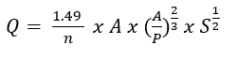
Where:
Q = flowrate in CFS (pipe capacity when parameters below are for a full pipe. CFS is cubic ft per sec)
n = Mannings “n” (use 0.012 for most smooth pipes)
A = cross‐sectional area of flow (pipe area when full) in square feet (SF)
P = wetted perimeter (pipe perimeter when full) in FT
S = pipe slope in FT per FT
The table below lists several pipe sizes available and their associated minimum required pipe slopes by size. Use the formula above to calculate the Flowrate (Q) for each given pipe diameter.
Pipe Diameter (in) | Minimum Slope (ft/ft) | Flowrate (Q-CFS)
8 | 0.0050
12 | 0.0028
16 | 0.0014
24 | 0.0008
One beneficial unit conversion is that 1 cubic foot = 7.5 gallons
- A sewer service area contains 900 homes and 400 apartments. What pipe size is required to convey the wastewater away from the area?

- A sewer service area contains 12 in diameter pipes and contains 1100 houses and 400 apartments. A real estate developer wants to come in and build an apartment complex, on some open lots, that will contain 400 new apartment units. Can the existing pipe system convey the wastewater away from the area, after building the new apartments? Explain your reasoning.

- We need to convey 300,000 GPD of wastewater, away from an area using a 12 in diameter pipe. What is the minimum slope requirement for the pipe? What does the minimum slope value represent as a fraction?
Task 2: Pump Stations
In order to convey the water uphill, the pump must overcome the static (static because it does not change) and dynamic head (dynamic because it is moving and head means pressure). Combined we call this “total dynamic head”. Static head is resulting from the slope uphill we are pumping the water. Dynamic head is the friction resulting from the inside wall of the pipe.
Total dynamic head (TDH) = Static head (SH) + Dynamic head (DH)
In hydraulics, we express “heads” in height of water column in feet.
For a force main piping system, the static head is constant, but the dynamic head changes with flowrate. It is a power relationship described as DH = k x Q^{1.85}
Therefore, TDH = SH + k x Q^{1.85} where, SH is the static head in FT, Q is the pumping rate in GPM, and k is a constant that is a function of the piping system that takes into account the length, diameter, and pipe wall roughness.
- Find the equation for the head loss, TDH, for a force main system with a static head of 30 feet and a piping system k‐factor of 0.0006. (It may help to think of TDH as the pressure at the beginning of the pipeline, as you try to apply common sense to these hydraulic terms.)

- What relationship exists between the pumping rate, Q and the head loss, TDH?
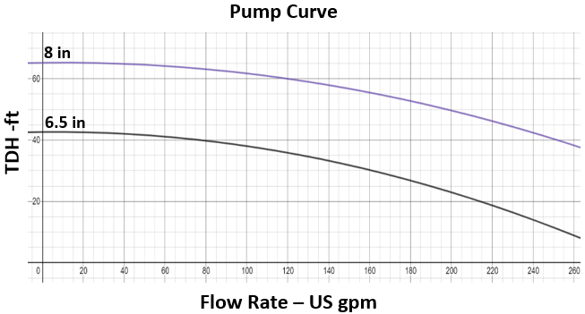
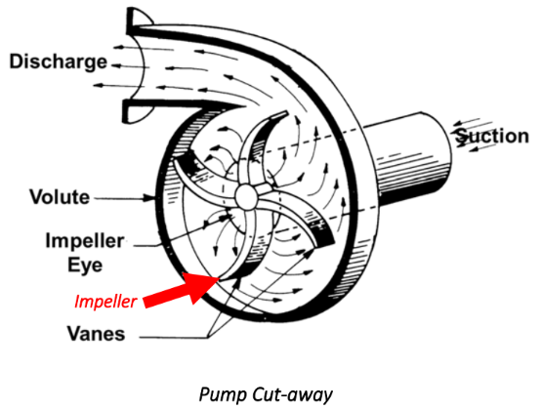
The most common pump used in wastewater conveyance is a centrifugal pump. For centrifugal pumps, the flowrate delivered by the pump is dependent on the TDH imparted by the piping system.

On the pump curve diagram above, two pump impeller sizes are shown: 6.5” diameter and 8” diameter. Where the pump curve and the system curve intersect is where the pump will operate.
- What is the expected pumping rate with each size impeller shown?

