Stormwater Management
Student Activity Sheet

Quantity: Is a stormwater management system needed?

CLH Design specializes in school site development and is contracted to develop stormwater management plans for the construction of South Lakes Elementary School. They have hired you to run the analysis for the pre- and post-development peak run-off of stormwater.

You need to analyze the pre-development peak run-off versus the post-development peak runoff at South Lakes Elementary School. This will allow you to determine if strategies need to be put in place for holding water back and releasing water at a slower, pre-development rate. Strategies for doing this include stormwater detention ponds (wetland), above-ground cisterns to capture roof runoff, and below ground cisterns to capture parking lot runoff.
$$C=\frac{∑(A_{i}C_{i})}{∑(A_{i})}$$  C: Weighted Average of Runoff Coefficient  $A_{i}:$ $Area of Surface Type [acre]$  $C_{i}$: Runoff Coefficient of Individual Surface Type | $$Q=C×i×A$$  Q: Peak Runoff [cfs]  $i:$ Rainfall Intensity of Design Storm [in/hr] (7.08-in/hr. for Wake County)  A: Total Area [acres]

Peak run-off refers to the maximum amount of run-off during a “design storm,” a hypothetical storm event based on historical data. In most fields dealing with the repercussions of weather (like stormwater management) there are design storms for 1-, 10-, and 25-year cases, e.g., the 25-year design storm for a given location is rare enough that it is only expected to be that severe once every 25 years. You may have heard of a 100-year flood zone, which is a similar concept: the zone will probably flood once in 100 years. The design storm is named because engineers take them into consideration when designing.

Individual Surface Type | Rational Runoff Coefficient, C | Water Penetration
Lawns, sandy soil, flat (<2%) | 0.1 | Pervious
Lawns, sandy soil, average (2-7%) | 0.15 | Pervious
Lawns, heavy soil, flat (<2%) | 0.15 | Pervious
Wooded areas | 0.15 | Pervious
Lawns, sandy soil, steep (>7%) | 0.2 | Pervious
Lawns, heavy soil, average (2-7%) | 0.2 | Pervious
Lawns, heavy soil, steep (>7%) | 0.3 | Pervious
Unimproved Areas | 0.35 | Pervious
Landscaped Areas | 0.35 | Pervious
Brick | 0.85 | Impervious
Roofs, flat | 0.9 | Impervious
Asphalt | 0.95 | Impervious
Concrete | 0.95 | Impervious
Roofs, inclined | 1 | Impervious

Pre-Development
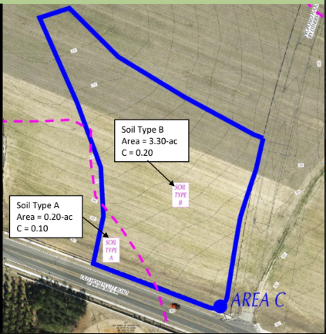
surface type:
average, heavy soil
area = 3.30 acres
surface type:
flat, sandy soil
area = 0.20 acres

Post-Development
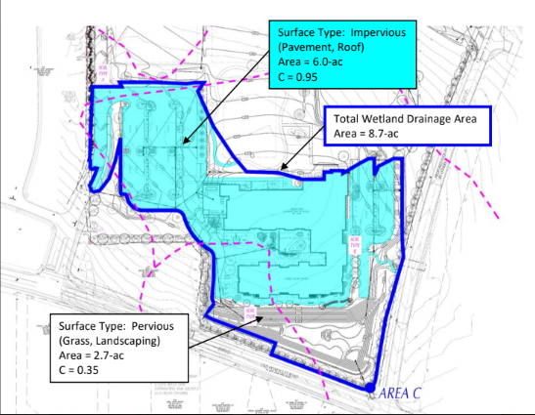
surface type:
asphalt
area = 6.0 acres
surface type:
landscaped
area = 2.7 acres

Task 1
Use the given pictures, reference charts, and functions to solve the following problems.
- Identify the variables in the C function as dependent or independent. Identify the variables in the Q function as dependent or independent. How does the role of the C variable change from the first function to the second function?

- Based on the images of the pre-development and post-development of South Lakes Elementary School, do you anticipate a stormwater management system being needed? Explain why or why not.

- Determine the pre-development run-off coefficient for the marked area.

- Determine the pre-development peak run-off for the marked area.

- Determine the post-development run-off coefficient for the marked area.

- Determine the post-development peak run-off for the marked area.

- Analyze your results to determine if a stormwater management system is needed. Use your solutions from previous questions to explain why or why not.

- Explain how this task relates to recent topics in class.

Activity 2
Now that you have determined a stormwater management system is needed, calculate the required wetland surface area and volume before you hand the project off to the landscape design architect team.

$$\% Impervious= \frac{Impervious Area within Wetland Drainage Area}{Total Area of Wetland Drainage Area}$$

$$R=0.05+0.009×\% Impervious$$

R: Runoff Value [in/in]

*% Impervious: use actual percentage, not decimal equivalence, i.e. 4.25%, use 4.25 not 0.0425
**0.05 and 0.009 are industry given standard values
$$V=Design Storm ×R×Drainage Area$$  V: Volume Required [make sure result is measured in ft³]  Design Storm: Use 1-in for Raleigh  Drainage Area: Total Wetland Drainage Area from Activity 1 [acre]  *Note: Unit conversions are required (1 acre = 43,560 $ft^{2}$) | $$SA=\frac{V}{d}$$  SA: Surface Area of Wetland [$ft^{2}]$  d: Depth = 15-inches maximum (industry standard)  *Note: Unit conversions are required

- Calculate the volume of the wetland.

- Calculate the surface area of the wetland.

- Explain how the % of impervious surface indirectly affects the surface area needed for a wetland.

- The landscape architect team has a design that provides 18,000 $ft^{3}$ of volume for the wetland. Construct a proposal to the client justifying why the team’s plan will or will not work. Include your findings from the previous questions in Part 2 to justify your proposal.

