Solar Energy
Student Activity Sheet

What is the maximum annual energy output for your school’s roof?

Your school is planning to add solar panels (also called modules) to a flat roof. You are working to maximize the annual energy output of a rooftop solar photovoltaic (PV) array.

Photovoltaic (PV) – a process that converts light energy (photo) into the flow of electricity (voltaic).
PV panels – “solar panels” utilize thin wafers of crystalline silica to convert the sun’s light
energy into usable electricity.
Array – a group of multiple PV panels linked together to generate electricity. This electricity can
either be used by the building and/or sold back to the electric grid for use by other customers.
Solar Radiation Angle – the angle between the suns rays and the horizontal plane as pictured in the figure in part 2 of the project.
Tilt Angle – The angle the solar panel makes with the roof.

- Each PV panel is approximately 3’ H x 5’ L x 0.5’ D
- Panels can be placed next to one another to form long continuous rows.
- Maintain a distance of at least 4’ between PV panels and roof edges.
- There is a rule of thumb for determining the best tilt angle for fixed-mount solar panels. The tilt angle should be equivalent to the latitude of the location.
- The solar radiation angle is 30$°$ at Garner Magnet High School.

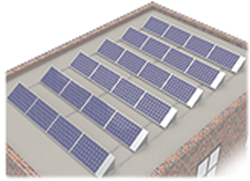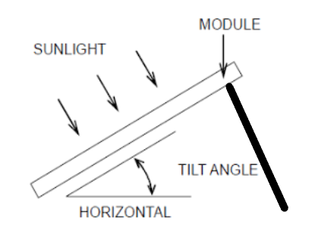

Mounting Bracket
https://www.solarelectricsupply.com/resi

Task 1: Determine the best Mounting Bracket Length and Angle with Solar Panel for Garner High School.
You have five options to choose from. These five options are outlined in the table below. There is a rule of thumb for determining the best tilt angle for fixed-mount solar panels. This means that the tilt angle should be equivalent to the latitude of the location.
- What is the tilt angle (latitude) for Garner, NC? (Hint: a quick google search will help you with this one)

- For each of the following bracket lengths and angles, determine the corresponding “tilt angle”. Show all algebraic work for full credit.

Mounting Bracket Length | Angle with Solar Panel
20” | 105$°$
25” | 85$°$
29” | $$85°$$
30” | $$70°$$
33” | 55°
- Based on your answers to #1 and #2, which bracket length and Angle with Solar Panel should be used for Garner, NC?

Bracket Selected: Length______________ Angle with Solar Panel______________

Task 2: To determine the distance between panels.

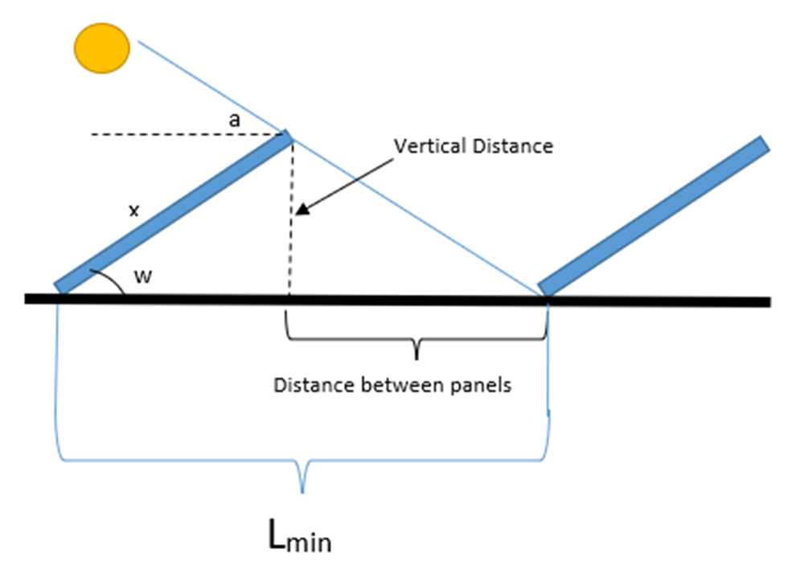
Being able to fit more panels on a roof usually increases output, but not when panels start to shade one another. To eliminate your solar panels from casting a shadow on the panels in front of them, you need to determine the distance between each row. L_{min} is the distance from the front of one panel to the front of the next. The general dimensions of a Solar Panel is 3’ H x 5’ L x 0.5’ D. Figure 2 is the image of solar panels mounted on a flat roof. Remember to show ALL algebraic work!

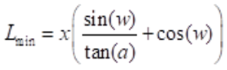

x = solar panel length
w = tilt angle
a = solar radiation angle

- Determine L_{min} for the Solar Panels.

- What is the distance between the Panels?

- Why is it important to install the panels with the distance you found in #2 between them?

Task 3: Determine the Maximum Energy Output for Garner Magnet High School
Now that we know which Mounting Bracket to use and the spacing between the rows, we need to decide how many panels are needed and how to arrange them. Remember that each PV panel is approximately 3’ H x 5’ L x 0.5’ D, they can be placed next to one another to form long continuous rows, and you must maintain a distance of at least 4’ between PV panels and roof edges. Remember to show ALL algebraic work for full credit.
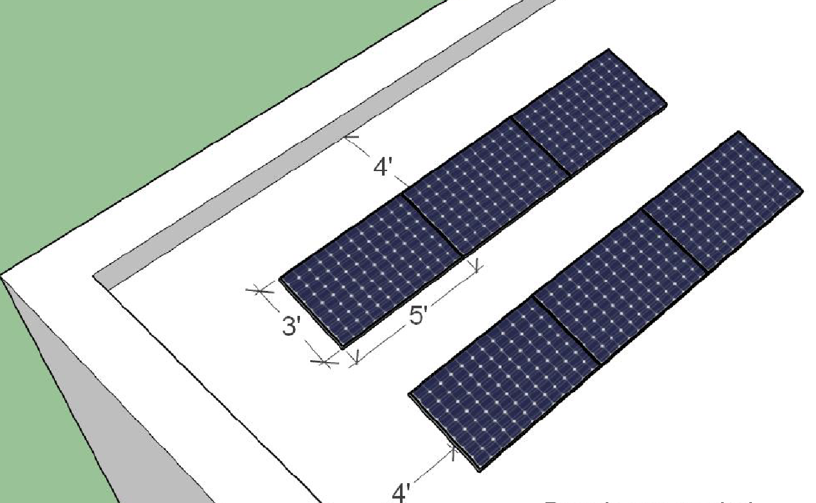
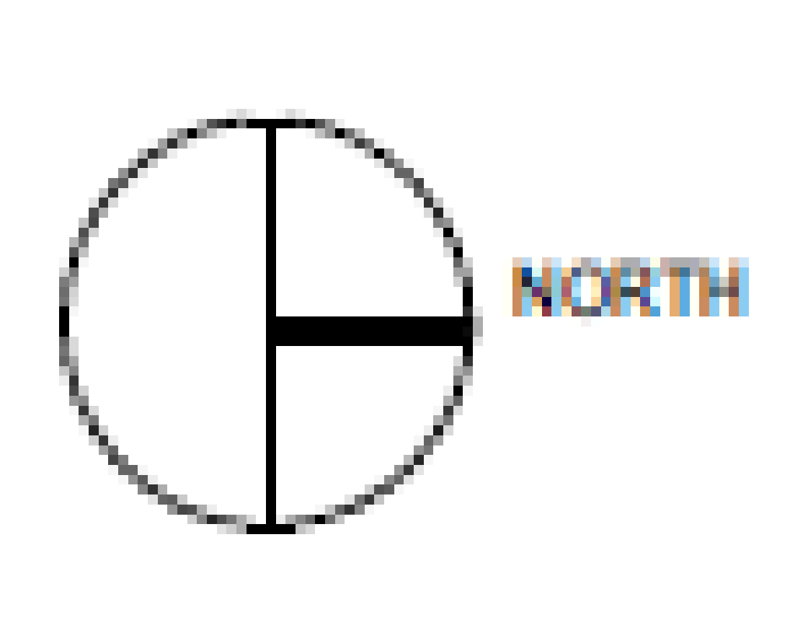

90 ft

Roof
42 ft

- Determine the number of panels required if you faced them:

North: ____________

East: ______________

South: ____________

West: _____________

Now that we know how many solar panels can fit on the roof, we can calculate the maximum annual energy output for Garner’s roof.
- Using the table for energy output, determine the energy produced for each configuration:
Annual Energy Output for PV Panels in Garner, NC
Panel Direction | Annual Energy Output (kWh Per Panel) | Total Annual Energy Output  (kWh)
North | 312
South | 592
East | 474
West | 471

3. What is the maximum annual energy output for your school’s roof?

