

**Loads of Steel - Student Activity Sheet**

Structural steel is used for almost every type of modern construction, including heavy industrial buildings, high rise buildings, infrastructure, bridges, towers, airport terminals, pipe racks, etc. The steel material is fabricated with specific shapes and chemical compositions depending on the project specifications.

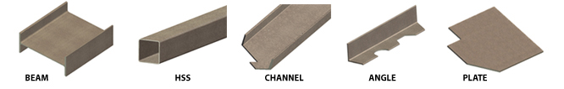

Because of the high strength grade of steel, it is reliable and can withstand extreme conditions such as strong winds and earthquakes. Structures composed of steel also require less raw materials; it is inexpensive to manufacture and requires less maintenance, making it economically efficient. Steel also allows for long spans of structure without column supports, creating much-desired natural beauty and light.

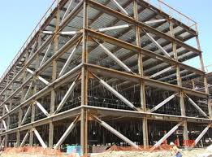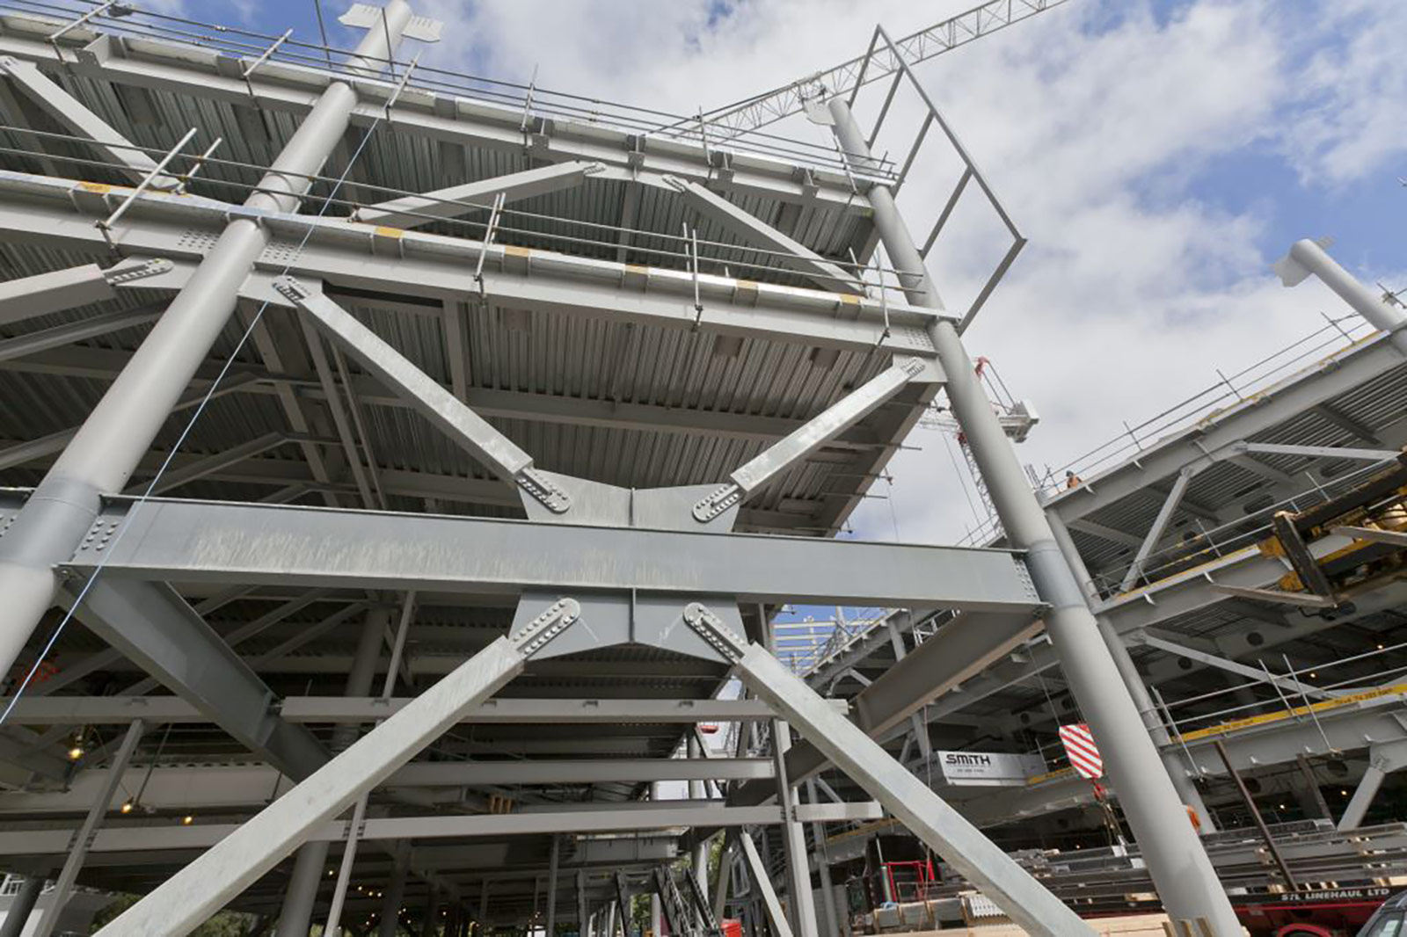



You are an engineer for SteelFab, Inc., one of the nation’s largest steel fabricators. Your team has been tasked with designing a parking structure. First, you must decide how thick the structural steel beams must be to withstand the load (weight), which is dependent upon different forces acting upon each beam. Kips are the unit of measurement that we use to measure force, 1 kip = 1000 pounds of force. Then, you will use this data to calculate an estimate of the cost to design the structure.

Part I:

Below is a diagram of the parking structure. This is a model of a two-bay, 3-story steel-framed building. Each bay is 30-ft wide and each level is 15-ft tall. The building depth is 20-ft. There are three different braces with different forces acting upon them: F3 = 110 kips, F2 = 100 kips, and F1 = 90 kips.

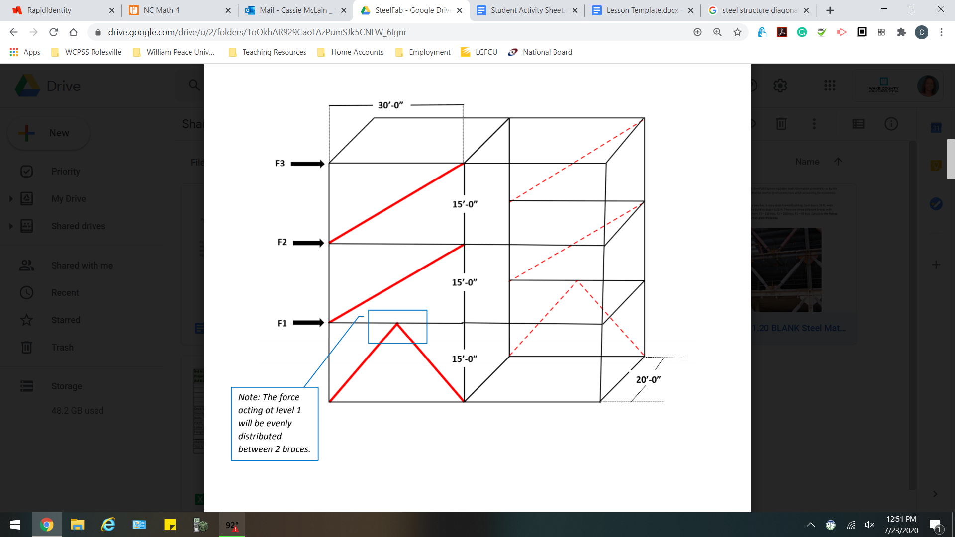

1. Each diagonal brace must support the sum of all lateral forces at or above the brace; for example, the total force acting on F2 must also include the force acting on F3. What would be the lateral force, measured in kips, exerted at each level?
2. The force in each diagonal brace is found by dividing the lateral force (found in question 1) by the ratio of the horizontal beam length to diagonal brace length.

What force is being applied on the diagonal brace at each level?

1. Leonhard Euler, a Swiss mathematician, physicist, astronomer, and engineer, was credited with developing a formula giving the **critical buckling load of a beam,** (PCR), which depends on its length and flexural stiffness. The critical buckling load of a beam is the maximum compression the beam can hold before buckling. The image below shows where the diagonal brace connects to the beams. At this connection, we form the “compression zone”.

Euler’s equation helps us determine the maximum compression for various plate thicknesses before buckling occurs. The equation we use to determine the critical buckling load is:



The values of the variables in Euler’s equation are based on the chemical composition, lengths, and

thicknesses of the metal. For this parking structure, we will use the following values based

on the steel selected by the consumer.

E = modulus of elasticity (material strength) =  for steel

I = stiffness = $\frac{bt^{3}}{12}$ for plates

A = area = $bt$

b=width of the brace

t=thickness

L = length of compression zone = 24 inches

b = width of brace = 18 inches

t = steel plate thickness

* 1. What are the units for  ?
  2. Find  in terms of t.

1. For safety precautions, SteelFab, Inc. assumes a factor of safety of 2.0 to ensure the structure is much stronger than it needs to be for an intended load.
   1. Determine the  after taking the safety measures into consideration.
   2. Explain in complete sentences why we divide by 2 if we want to double the safety?
2. Steel plates are designed with various plate thicknesses: 0.25 inches, 0.375 inches, 0.50 inches, 0.625 inches. Using Euler’s Equation and the forces you calculated in question 2, determine what plate thickness is required for each diagonal brace.
3. After choosing the beam thickness needed, determine the new safety factor being applied to 3 decimals. Then, write a statement summarizing your final recommendations for the plate thicknesses and total safety built into the design.

Part II: [Estimating Costs - Template](https://drive.google.com/a/wcpss.net/open?id=19wQE0IJHmPQeHW5UYW21xrM6QBVARS7n)

In addition to determining structural steel loads, SteelFab, Inc. provides the consumer with a construction bid of the total fabrication cost. Estimators with SteelFab use Excel to aid in the calculations. Use the information below to complete the spreadsheet to determine the total fabrication cost of the parking structure.

* A typical office building weighs 16.5 pounds per square foot
* 2000 pounds = 1 ton
* It takes 11 man hours to produce 1 ton of steel
* Labor costs $50 per man hour
* 1 deck square = 100 square feet
* 1 deck square costs $185
* 1 ton steel structure material costs $850
* 1 ton steel bolts costs $35
* 2 gallons paint covers 1 ton steel
* 1 gallon paint costs $15
* 1 truck load carries 16 tons of steel
* 1 truck load costs $600 per load

1. Write a statement summarizing the costs of the project. If SteelFab, Inc. is competing for a bid, in what area(s) could you cut costs to reduce the budget? In what area(s) can costs not be changed? Discuss the pros and cons of making these types of adjustments.