Let’s Get Mechanical: Outside Air Requirements and Heating Load
A Practice Understanding Task

Purpose: To determine outside air requirements and heating loads required for building design

Career Field: Moseley Architects

WTCC Associate Program of Study and Contact Person:
Mechanical Engineering Technology
Steve Hudnut

NC Math 4 Standards:
N/A

Unit Alignment:
WTCC Math 121
WTCC Math 110: During unit 2 (Chapter 3 Geometry Lab/Application)

Common Core State Standards for Mathematical Practice
1. Make sense of problems and persevere in solving them.
2. Reason abstractly and quantitatively.
3. Construct viable arguments and critique the reasoning of others.
4. Model with mathematics.
5. Use appropriate tools strategically.
6. Attend to precision.
7. Look for and make use of structure.
8. Look for and express regularity in repeated reasoning.

Prerequisite Skills
- Converting units
- Dimensional analysis
- Evaluating expressions
- Proportions
- Special right triangles
- Areas, perimeters

Time Required
The time required to complete this activity is approximately 120 minutes.

Materials Needed
N/A

The Teaching Cycle:

Launch:
[Show video about Mechanical Engineering Technology program/problem intro
Give students activity sheet and floor plan (optional: hand out student activity sheet and floor plan one or two classes in advance).]

Warm-ups
- Determine the area of the rectangle below, in square feet. Round to 2 decimal places.
- Determine the area of the rectangle above, in square meters. Round to 4 decimal places.

- Determine the two missing side lengths and find the area of the following figure:
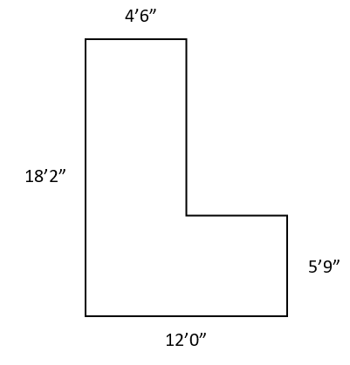

Task 1

Explore:
Students will work in pairs to complete task 1 from the student activity sheet. Together they will, calculate the outside air requirements for the first floor. Using the provided information, determine the outside air requirements for each space.

Discuss:
Have the groups share their answers for the area of the library. This should lead to a good discussion about how each group determined the area. Continue and have the groups share the Space Occupancy and Ventilation Rate for the Library. See if the students have similar or the same answers for these even though they may have gotten different areas.

Task 2

Launch
Video for problem 2: Heating Load Problem Introduction

Explore
Keeping a building warm in the winter and cool in the summer is a main concern for architectural design companies. In this activity, students will work in groups to determine the heating load for the walls and the windows. They will determine which one requires larger heating load and why.

Discussion
- For each room above (corner office, conference room, library) determine the component which contributes the most to the heating load.
- Explain why all three rooms did not have the same component that contributed the most to the heating load.
- Why is it not enough to just compare the area of windows to the area of walls?
- Consider the formula for the heating load $Q = UA (T_{i}-T_{o})$.
  - What will happen to the heating load if the height of the wall is decreased?
  - Suppose another wall assembly is chosen with “better” insulation. Should this correspond to a greater or smaller U-value?
  - Which month(s) of the year will the heating/cooling bills be most expensive? How does this relate to the formula?

Glossary of Terms
Heating Load - The maximum heat loss (typically expressed in BTU/hr or kW) during the heating season. The maximum heat load occurs when the outside temperature is the lowest.
U-Value - Rate of transfer of heat through a material or construction induced by temperature difference between the environments on each side $(BTU/(hr×ft^{2}×∘F)$

Exit Ticket:
N/A

