Cool Your Chickens
Student Activity Sheet
Morris and Associates is an Engineering Company located in Garner, NC. Their primary business is to build machines that cool with water. For example, they make machines that produce ice. They also build machines that cool chickens. You are hired by Morris and Associates to build a machine used to cool chickens. Your job comes in two parts. Your first job is to size the pulleys needed for the machine to operate at the proper speed. Your second job is to determine the correct size Clean in Place (CIP) rectangular tank for the system to clean between operating hours.

Below is an image of a poultry chiller.

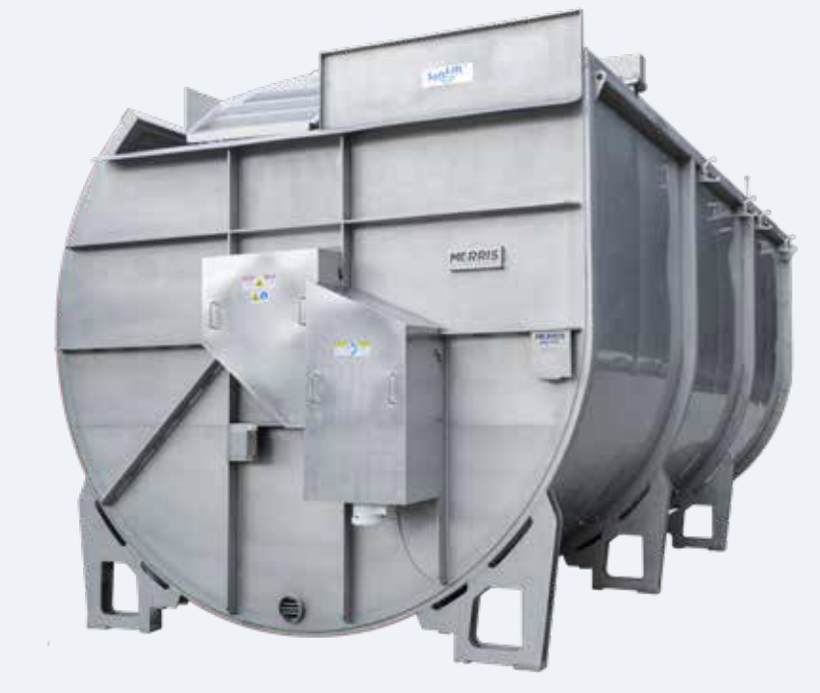

Task 1: Pulley Size
The machine has a motor which runs at a speed of 1725 rpm and has a gear reducer ratio of 1505:1. This gear reducer ratio means that for every 1,505 revolutions on the input side, there is only 1 revolution on the output side. This not only slows the rotation, but it increases the torque to rotate the huge auger by using a small motor inside the tank.

There are several pieces of this machine that utilize Diameters:
- Driven Sprocket Diameter, which is unknown,
- Drive Sprocket Diameter 6.8 inches,
- Drive Pulley Diameter 3.4 inches, and
- Driven Pulley Diameter 4.2 inches.

The images below show the different pulley systems used to reduce the speed of the system. Your goal is to reduce the shaft rotation to a speed of 0.333 rpm and to determine the Pulley Diameters needed to achieve this.

Many of these pieces of information are standard in the industry. For example, a motor with a speed of 1,725 is standard for this machine as is the gear reducer ratios and pitch diameters. The ratios are set up in the form of driven/drive = ratio.

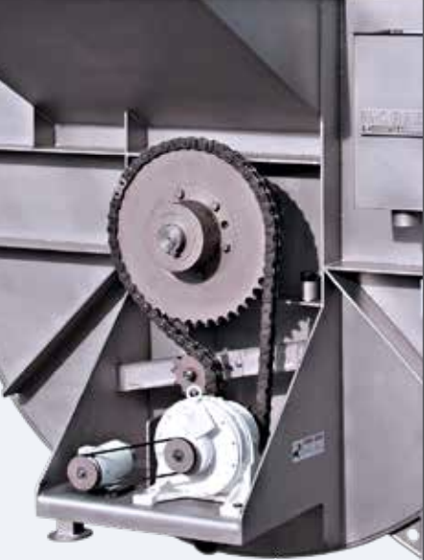

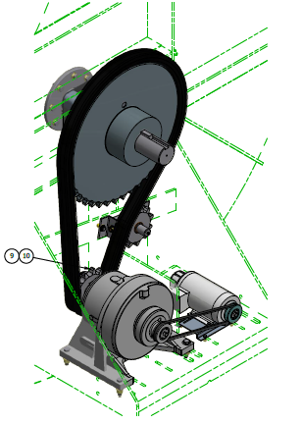
motor
Gear reducer
Drive Pulley
Driven Pulley
Drive Sprocket
Driven Sprocket
Main Shaft

- How many RPMs does the Driven Pulley rotate?

- What is the RPM of the Drive Sprocket?

- What Driven Sprocket diameter would produce 0.333rpm of the main shaft?

Task 2: Clean in Place Tank

During the day, water runs through the product chiller, the pipes, and the heat exchanger to help cool the chickens. At night hot, soapy water runs through the tubing, CIP tank, and heat exchanger in a loop to clean the tubing. This is why we call this a Clean in Place tank. The image below shows both the machine that cools the chickens and the pipes used for the heat exchange. The pipe distance to the CIP tank is 100’ and the pipe distance away from the CIP tank is 100’. All pipes have a 3” diameter. There are 11 elbows on the heat exchange unit. Each of these elbows has a length of 12”. Each tube in the heat exchange is 10’ long and there are 12 of them. You have to determine what size CIP tank to use so that there is always water running through the pipes with some in the tank.
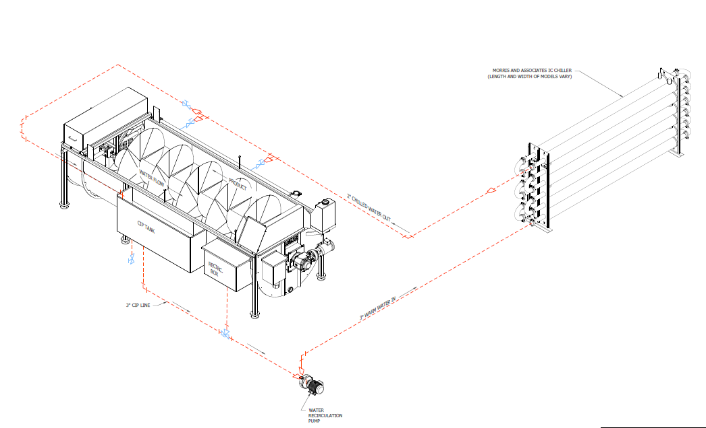
- The CIP tank must be filled with enough hot soapy water to clean the entire run of tubing. Industry standard is to size the CIP tank at least 15% more than the volume of the tubing so that there will be some water left in the tank after the tubes are filled. What size CIP tank should you put on the machine?

- If the height of the tank is 3’, recommend CIP tanks with 2 different sets of dimensions.

