Bill of Materials Calculations using Matrices
Student Activity Sheet

IBM Systems plan, design, test, manufacture and deliver some of the most advanced computing systems in the world. IBM products have complex structures requiring various sub-assemblies to manufacture our servers. In this example, you will leverage matrices to determine the required number of subassemblies required to build the Hydra Rack. The Hydra Rack is a cloud storage unit used to store information for super computers.
Bill of Materials (BOM) for a Hydra Rack are:
- Eight Hard Drives per one Disk Enclosure
- One Disk Enclosure per one Drawer
- One Drawer per one Base
- One Base is needed per one Hydra Rack.
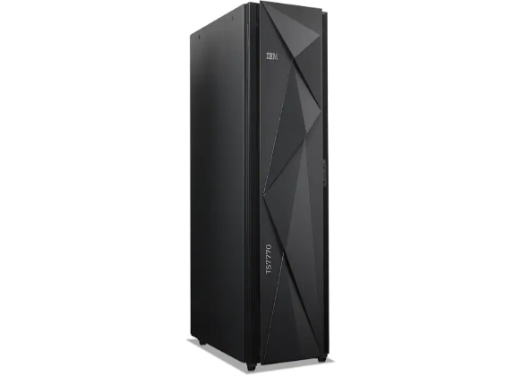
Below is a spreadsheet with a portion of a BOM
Completed Hydra Rack Assembly
Level 0 | Level 1 | Level 2 | Level 3 | Level 4
Hydra | 1
 | Frame | 1
 |  | Label1 | 5
 |  | Screw1 | 2
 |  | Bracket1 | 1
 |  | Door | 1
 |  | Rack | 1
 |  | Cover | 2
 |  | Switch | 1
 |  | Tie | 48
 |  | Cable1 | 1
 | Base | 1
 |  | Drawer1 | 1
 |  |  | Label2 | 4
 |  |  | Cardpop | 1
 |  |  | Port | 2
 |  |  | Disk Encl1 | 1
 |  |  |  | Hard Drive | 12
 |  |  |  | Carrier | 12
 |  |  |  | Screw2 | 48
 | Expansion | 1
 |  | Drawer2 | 1
 |  |  | Label2 | 4
 |  |  | Disk Encl2 | 1
 |  |  |  | Hard Drive | 8
 |  |  |  | Carrier | 8
 |  |  |  | Screw2 | 36

- Organize the data, using the names of the parts needed, in a matrix for Disk Encl1 and Disk Encl2. Explain the reasoning behind the organization of your matrix.

- Organize the amount of each component needed for one of each Disk Encl1and Disk Encl2 in a matrix.

- How many total components are needed to create Disk Encl1 and Disk Encl2?

- Let’s suppose we need the materials to build five Frames. Organize the total amount of each component needed to build five Frames in a matrix.

Could the data be organized in different ways within the matrix?

Does the organization of the data make a difference?
Frame Assembly Example

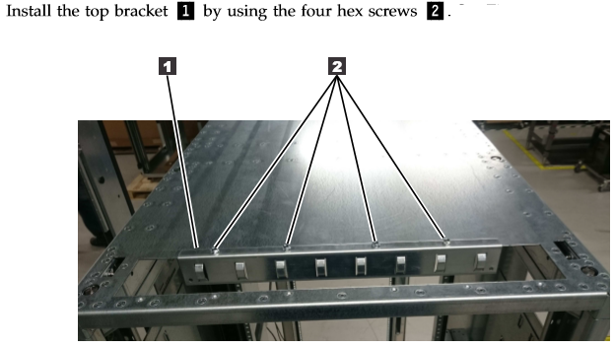

- The amount of materials you have available in your inventory for building the five Frames is listed below:

Bracket1: 250 Cable1: 100 Cover: 150 Door: 70 Label1: 310

Rack: 110 Screw1: 170 Switch: 100 Tie: 864

Do you have enough materials in your inventory to produce five Frames?

Using matrices, explain your conclusion.

What is the rationale behind the size of the matrix you chose?

- Using the remaining inventory from question 5, how many more Frames can be built?

Using matrices show how you came up with the number of Frames.

- Is it possible for Base Drawer components and Expansion Drawer components to be combined? Explain your conclusion.

Is there another set of components that could be combined with a Base Drawer or Expansion Drawer? Explain.

Below is a spreadsheet for the complete BOM
Level 0 | Level 1 | Level 2 | Level 3 | Level 4
Hydra | 1
 | Frame | 1
 |  | Label1 | 5
 |  | Screw1 | 2
 |  | Bracket1 | 1
 |  | Door | 1
 |  | Rack | 1
 |  | Cover | 2
 |  | Switch | 1
 |  | Tie | 48
 |  | Cable1 | 1
 | Base | 1
 |  | Drawer1 | 1
 |  |  | Label2 | 4
 |  |  | Cardpop | 1
 |  |  | Port | 2
 |  |  | Disk Encl1 | 1
 |  |  |  | Hard Drive | 12
 |  |  |  | Carrier | 12
 |  |  |  | Screw2 | 48
 | Expansion | 1
 |  | Drawer2 | 1
 |  |  | Label2 | 4
 |  |  | Disk Encl2 | 1
 |  |  |  | Hard Drive | 8
 |  |  |  | Carrier | 8
 |  |  |  | Screw2 | 36
 | Server | 1
 |  | Cable2 | 15
 |  | Clip | 12
 |  | Bracket2 | 5
 |  | Enclosure | 2
 |  | Screw3 | 8
 |  | Assembly | 2
 |  |  | Adapter | 5
 |  |  | Cable3 | 4
 |  |  | Ram | 36
 |  |  | Memory | 4

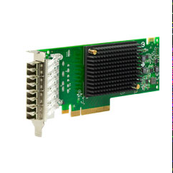
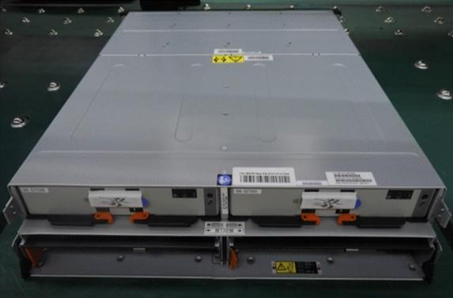

Adapter Assembly Example

Drawer Assembly Example

- If six complete Hydra Rack units are needed, how many Assembly components will be needed? Explain two different ways the value of this situation could be found.

- Let’s suppose there are several different orders for a Hydra Rack Server: One going to North Carolina, two going to Canada, four going to Germany, six going to Hungary, ten going to Mexico, and seven going to China. How many components are needed for enough of the Server components for the six orders? Use a matrix to show the process for determining the number of components needed to complete the order. Is there a benefit to organizing the data in the matrix the way you chose to do it? Explain.

- Your build partner Colin is trying to figure out the amount of Disk Encl1 and Disk Encl2 components needed to complete an order for Durham, NC. The company requesting the components needs six Disk Encl1’s and eight Disk Encl2’s.

Colin has determined the total component amount to be $\left|360 136 352 \right|$.

When you do the calculations, you determine the total component amount to be $\left|136 136 576 \right|$.

Who is correct? Explain your conclusion.

